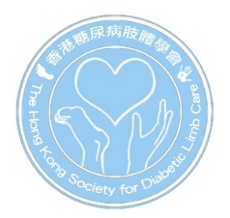
2026 Symposium on Diabetic Wound Healing
8:30 – 17:00, 7th February 2026
Seminar Room 4, Laboratory Block, 21 Sassoon Road, Pokfulam, Hong Kong

Registration Form

Title | Prof. / Dr. / Mr. / Ms. | Profession | Doctor / Nurse / Pod / P&O
Family Name |  | Given Name
Department |  | Institution
Email |  | Contact Number
Correspondence Address

Category (please circle) | Early-Bird Registration Fee  (Before 17 Jan 2026) | Registration Fee  (After 17 Jan 2026)
Lectures + Workshop 2 Only | 500 HKD | 700 HKD
Lectures + Workshop 1 and 2 | 1000 HKD | 1200 HKD

As the quota of workshop is limited, we cannot guarantee success with all applications. Successful applicants will be notified via email.

Please send this registration form together with the cheque payable to " The Hong Kong Society for Diabetic Limb Care Limited " to:  Mr. Toma Pun  LG 102, Block K, Queen Mary Hospital, 102 Pokfulam Road, Hong Kong  Enquiry: info@diabeticlimb.hk  Website: https://www.diabeticlimb.hk | 